**Nine Square Puzzle**

Write a program to solve the puzzle shown below. To solve the puzzle, arrange the tiles in a 3x3 grid such that wherever two squares touch the touching numbers sum to zero (examples below).

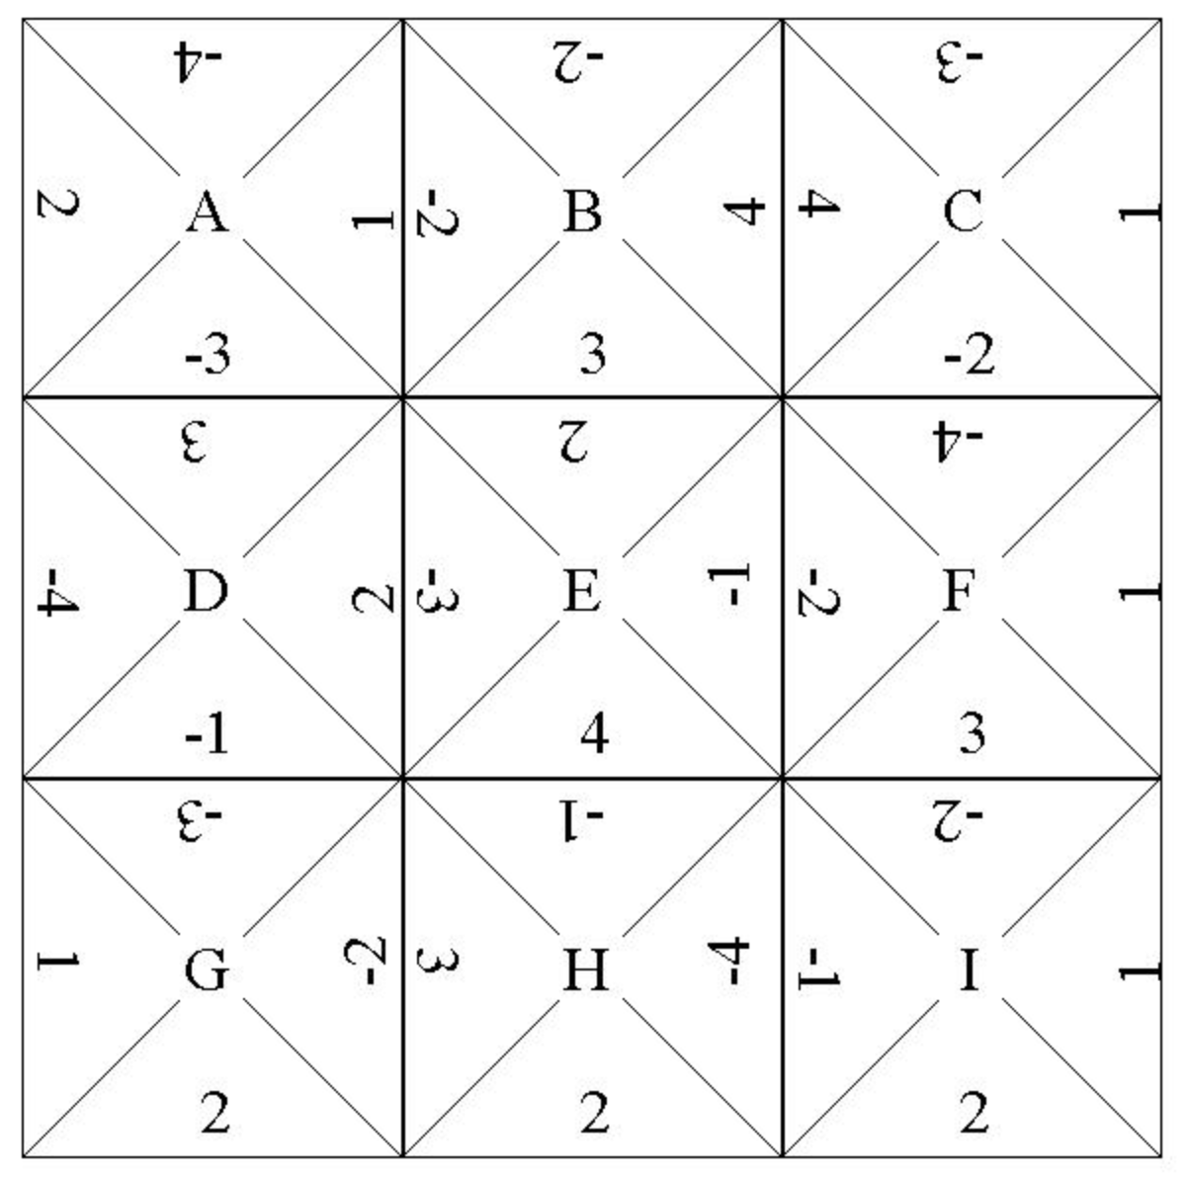

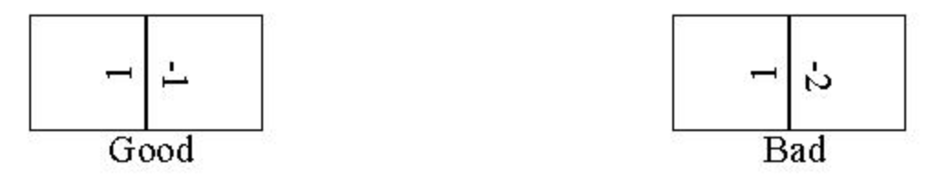

You are welcome to print this page out, cut out the squares and try to solve this puzzle by hand, but be aware that there are ~95 billion ways to arrange the tiles. Only four of these ways result in solutions of the puzzle shown above.

**Hints:**

* Create the necessary abstractions before beginning with the recursion.
* If you would like to make a fast solution, you're going to need to do some ***pruning*** - terminating a chain of exploration that can't possibly lead to a solution.